BOOKING FORM – Oxford Cambridge ARC Development Conference;
Doubletree Hilton, MK Dons Stadium, Milton Keynes; 18th June 2020
Name* | Job Title*
Company* | Mobile*
Address*
 | Post Code*
Email*
Guest Details – Please reserve me the following spaces at this event:
Guest Name | Job Title | Company
1)
2)
3)
Total Cost (£179.00 per person) + VAT
Please give details of any delegates UNDER the age of 18 yrs old
Payment Method
Cheque: Payable to Built Environment Networking Ltd (please attach)
Credit Card: Master Card Visa Invoice
BACS: HSBC Bank p/c. Sort Code: 40-27-43; Account Number: 60026069; Reference Name and event date
Cardholder Name
Card Number.
Security Number
Expires

Please do NOT EMAIL Credit Card details for security reasons. Please print and send via post
National Partner - WILLMOTT DIXON
Please send this form, together with BACS/Credit Card Details/
Cheque to: Maxine Poole, Built Environment Networking Ltd, 4235 Park Approach, Thorpe Park, Leeds, LS15 8 GB
Email: maxine.poole@built-environment-networking.com or Alternatively please: Pay Online: www.built-environment-networking.com. Bulk Ticket Discount: Please contact us for details of the discounts available for the purchase of bulk tickets to our events. Please note that bookings are transferable, however refunds will only be given 14 days prior to the event, Speakers and timings may change due to unforeseen circumstances
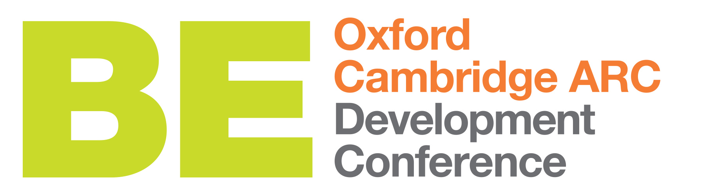
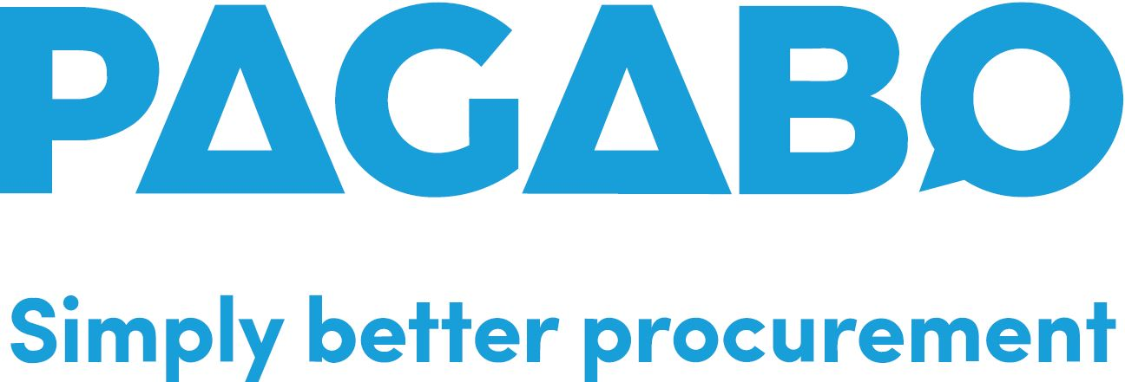

PARTNERS/SUPPORTERS

